**EXPERIMENT -4**

(BY: AMAN TYAGI)

**AIM:** To use the concept of Docker Volume.

**Steps:**

-Running a docker container

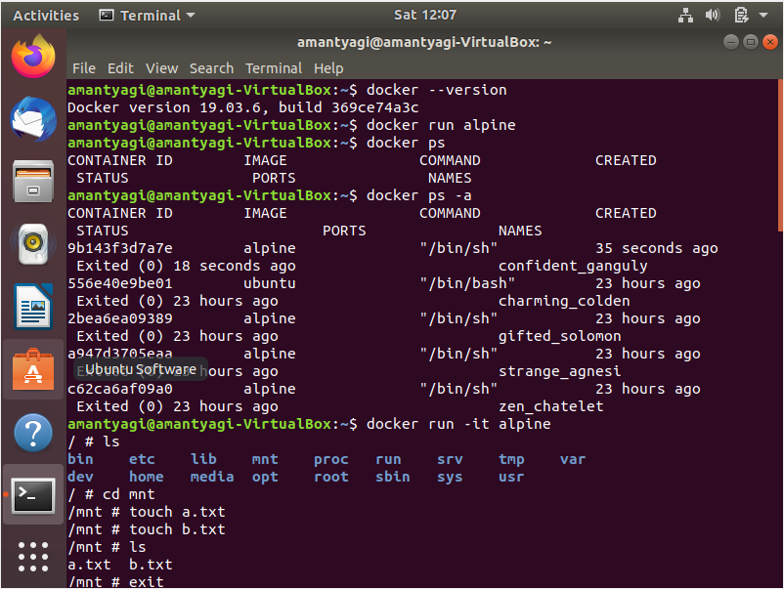

-Creating a volume and linking to a specific directory

-Creating a file in that directory.

-Running “docker volume ls”

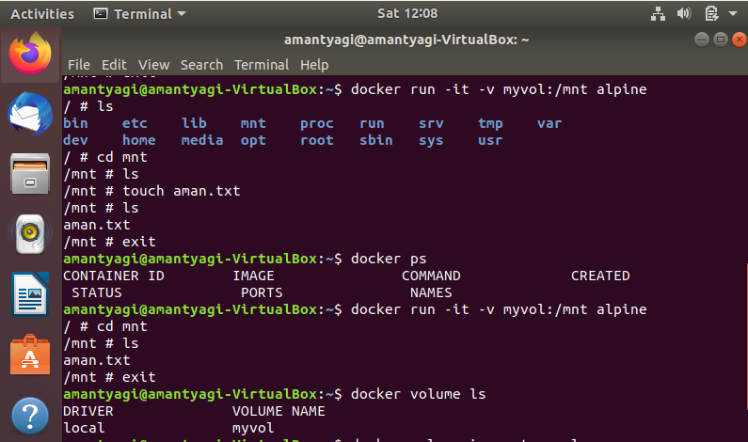

-Running “docker volume inspect”

-Checking for the created file at the mount point

- Running second container to link to the same volume

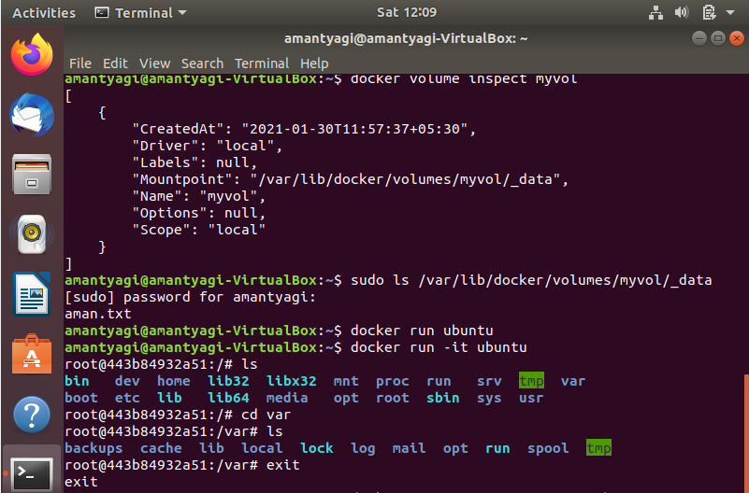

- Creating a second file in another directory

- Again checking the mount point to see both the files

